Adult Learning 19+
Booking Essential
**FREE tuition for people on most means tested benefits (proof required at first session)

Creative Writing: Short Stories Next Steps
Stapleford Library
If you want to find out what it takes to write a publishable short story, this course is for you. Our Short Stories Next Steps writing course will help you to create credible plots and structure your story as well as showing you how to present your work ready for publication.

One of the enjoyable things about short stories is the sheer variety of the markets for which you could be writing, women’s magazines, local newspapers, competitions and festivals, small press magazines. This course will show you how to research and meet the demands of these markets.
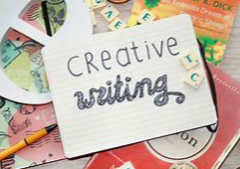

Starts: Sat 14th Jan 2023
Time: 10:00 – 12:00
For: 5 Weeks
COST: £35.00

Stapleford Library
Church Street
Stapleford
Nottingham
NG9 8GA

