5th November 2021
Dear Parents/Carers,
I hope you are well and have had a lovely half-term break. It is fantastic to see our students back and to hear about some of the lovely activities they have been taking part in over the holidays.
This week we have been celebrating Diwali and learning about keeping safe around fireworks. It is striking that whilst there is so much light in our celebrations, the days are getting shorter and this time of year can be challenging for some people. Please do let us know if we can support with anything – we are here to talk through any concerns you may have.
Diwali Celebrations
Foxcubs class celebrated Diwali with their own celebration yesterday. Helen and the team painted diyas, sampled some foods and created their own Rangoli patterns. It was great to see our students joining in and celebrating Diwali with their friends and learning about this important festival.
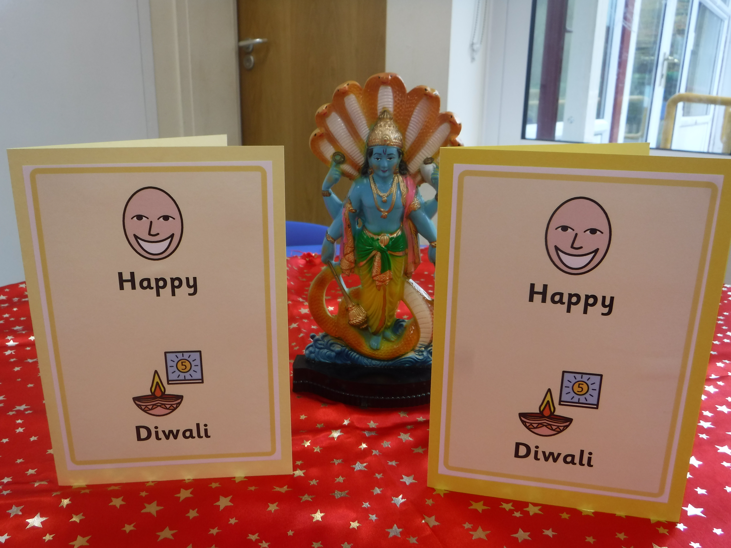
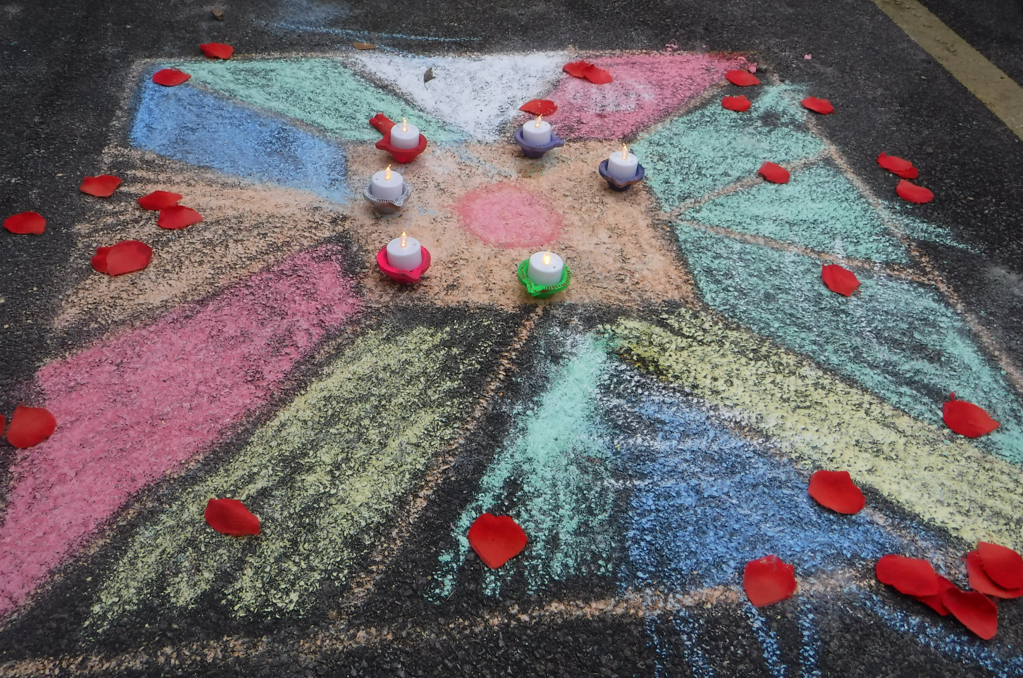
Medium Term Plans
You should have received a copy of the new medium-term plans for your child this week. If you have not received a copy, please can you ask your child’s class teacher for one in the planner. We send out these plans so you have an overview of what your child will be learning each term and to allow opportunity for topics to be shared at home.

E-safety
As the days are getting shorter, we naturally spend more times indoors and on screens. I would like to share with you some advice and tips for ensuring your child is using the internet in a safe way, and to signpost you to some helpful websites. The UK Safer Internet Centre has a bank of resources and information available and I have attached the link below:
https://www.saferinternet.org.uk/advice-centre/parents-and-carers/parents-guide-technology

Key Dates
On Friday 19th November, we will be having a very special visit from Pudsey Bear for Children in Need. Further information will be sent out next week about our plans for Children in Need.
A reminder that there is an INSET day on Monday 22nd November and the Academy will not be open to students on this date.
We are planning to hold a primary Christmas production on Thursday 16th December in the afternoon. All children will have the opportunity to share their work and to sing some carols. More details will be sent in the next couple of weeks but I wanted to make you aware of the date now.
We will be holding a Christmas fair on the 8th December in the afternoon. Again, more information will be sent out about this in the next couple of weeks.

Warm clothing
Please can we remind you to send in a warm coat as the weather is getting colder. We will still try and get outside during breaktimes even in the rain so it is important your child has a warm, waterproof jacket. You may also wish to send in hats and gloves but please remember to label any items that may be sent in.

Horse Riding
Squirrels class went on their first horse-riding trip on Thursday 4th November. It was so lovely to see our young people out in the community again after missing out on these important opportunities last year due to Covid-19. I was so proud of their determination, resilience and manners during the session. Well done Squirrels for making the staff at Foxwood very proud!
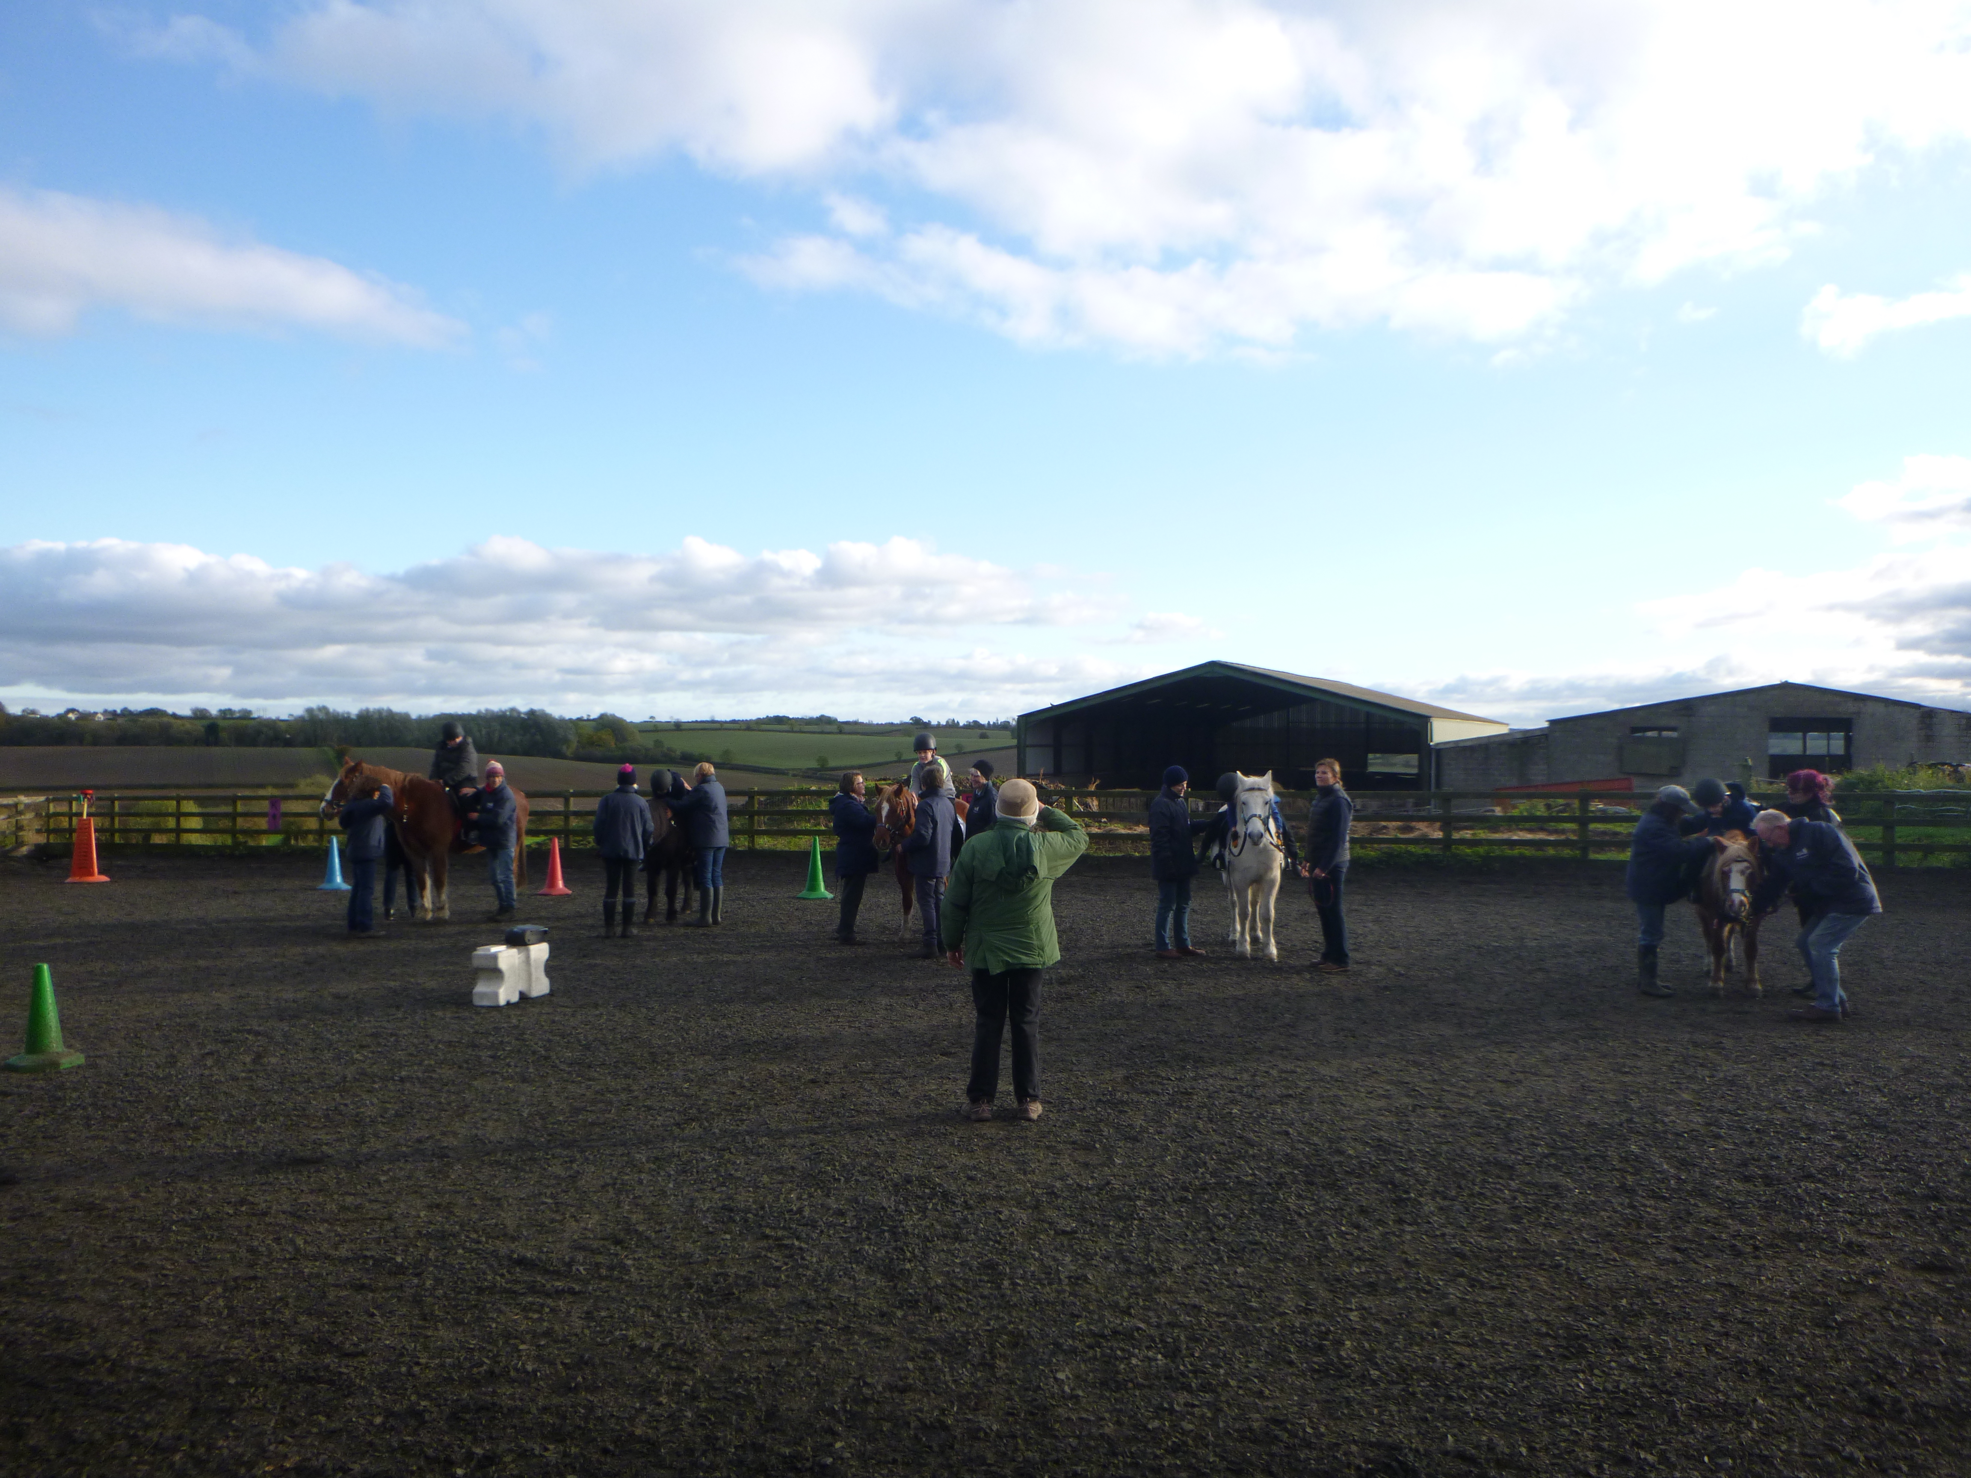
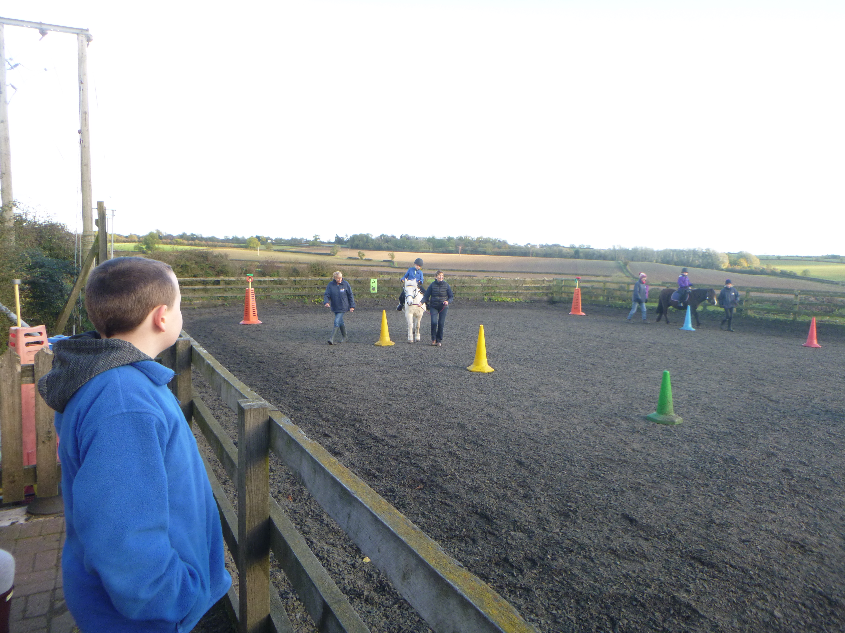

As you can see, it has been a very exciting, busy first week back and I look forward to meeting you all again at some of the events we have planned during this half-term.
Keep safe this weekend and thank you as always for your continued support.
Yours sincerely,

Robbie Jones
Primary Phase Leader

