8th September 2021
Dear Parents/Carers
Welcome back!
A warm welcome to everyone, especially to all of our new families. Welcome to the Foxwood Family.
Almost all of the children and young people have now fully returned and, as usual, they have amazed us with how resilient, hardworking and adaptable they have been. We had our first face to face assembly last week and it was like we were never away.
For those that have had permission, we have been completing covid tests in school this week and will provide more testing kits for you to continue testing at home. If you need any help, any information or need to talk to us about using the kits then please contact us at school. Although we are now moving to fewer restrictions in school, we still would ask you to ensure the children and young people are still washing their hands before they come to school in the morning and are still practicing good hygiene protocols where they can (catch it, kill it, bin it!).
If your circumstances have changed over the summer, or your children’s behaviour has changed and you need any advice or support please remember to contact us at school so that we can try to help. We may not always have the magic solution, but we can certainly try to signpost you in the right direction.
Please make a note of Wednesday the 22nd September 2021, this is our Meet the Teacher evening starting at 4.00pm or 4.45pm (you can select a session). You will have the opportunity to meet with class teachers, ask questions about the curriculum, free school meals, EHCPs, talk to our Academy chef and hopefully meet other parents and carers. Another important date is Friday, 12th November 2021; this will be our re-arranged Leavers Prom. We will contact you about this separately.
We have an exciting year ahead and we look forward to meeting with you all again soon.
Yours faithfully
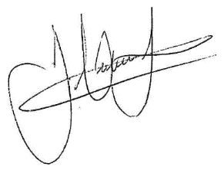
James Hutchinson
Headteacher

