1st April 2021
Dear Parents and Carers

Easter celebrations and the start of Ramadan will soon be upon us. It gives us a natural break and hopefully a time to take stock and reflect on a very busy and unusual year. Our hearts go out to all our friends, staff, children and families who have lost loved ones.

As we look to the summer term we are excitedly planning presentation evenings, our prom and are in the process of booking residential trips for early in the new academic year. Our children and families have been on the front line of this pandemic and we are keen to take the children away, celebrate being part of Foxwood, build and nurture relationships and catch up on lost learning.

As ever we continue to update our website and social media pages with Foxwood news. Some of you may have noticed a new ‘tile’ on the website called ‘Foxwood Community’. On here you will find links to courses, training, forums, news and information specifically linked to parents and carers in our community. Most of the training is provided online and is either free or offered at a reduced cost. I would highly recommend that you have a look and also point you in the direction of our new Foxwood Facebook group which is open for you to join.

This term we say a sad farewell to our Academy chef Helen. Helen has worked at Foxwood for many years and will be greatly missed by all of us. Helen would like to pass on that she has thoroughly enjoyed working with such special people and wanted to say thank you. We wish Helen all the best as she moves into her new home and starts to spend more time with her family.

With that I wish you a restful break. Please enjoy looking through our newsletter, remember to report any positive COVID-19 cases over the break to: positivecase@foxwood.notts.sch.uk and those testing at home please continue to report your results to:

Report a COVID-19 rapid lateral flow test result - GOV.UK (www.gov.uk)

And:

Reporting results to school

Kind regards
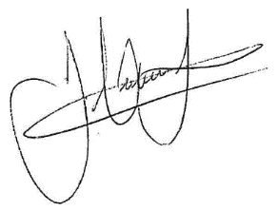
James Hutchinson
Headteacher

