22nd March 2021
Dear Parents/Carers

Secondary aged children only

As you may know, we have been completing COVID19 testing at the Academy since January. The process has gone very well and we have been pleased with the way our children and young people have adapted. When we list our values at Foxwood we talk about ‘Learning for Life’ and ‘Independence’. This testing has certainly helped in these areas and we are confident that many of the skills and behaviours will stay with our children.

Testing over the Easter break must continue and we have been instructed to provide all secondary aged students with testing kits.

From the 22nd March we will be sending kits home. The kits are relatively simple to use and come with full instructions. You will be asked to test twice a week and we recommend WEDNESDAY AND SUNDAY.

We will be asking you to register your results with Foxwood and with NHS Track and Trace and will provide further information on how to do this before the break.

You will receive enough tests to take you up the beginning of June, if you have problems administering the tests or you need support we will be able to help with advice. If it becomes too difficult it may be that we are able to continue testing in school.

For further information please contact us at school.

Kind regards
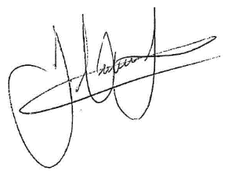
James Hutchinson
Headteacher

