12th February 2021

Dear Parents/Carers

Is that a glimmer of light at the end of the tunnel? We hope so….

Many of our staff have now been vaccinated against COVID19 and despite some adverse reactions for a few of us we are all now feeling happy and looking forward to getting back to normal.

Should your child receive a positive test for COVID19 over the holiday please email: positivecase@foxwood.notts.sch.uk

You may have seen that announcements are coming after half term regarding dates for returning to schools. A number of children have remained home during this second/third lockdown but we would now strongly recommend that they return from 8th March 2021 at the latest unless you have been advised otherwise.

We continue to test all staff for the virus on a weekly basis and will test secondary aged children and young people on their return. The testing is not compulsory and we can support those with more complex needs. If you child has not yet been tested for COVID19 and they are 11 or older please complete the consent form so that we can continue to keep everyone safe.

Foxwood have recently invested in ‘medical tracker’, which is a system that tracks medication, records first aid incidents, and helps with communication. It may be that in the future, if your child receives first aid you will receive a short email with the details. If you have any questions about this please contact us at the Academy.

Kind regards

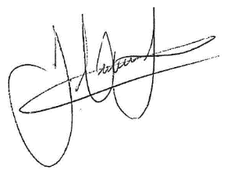

James Hutchinson
Headteacher

