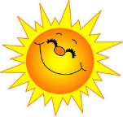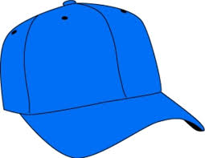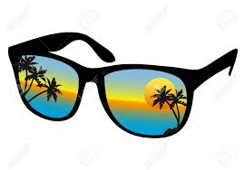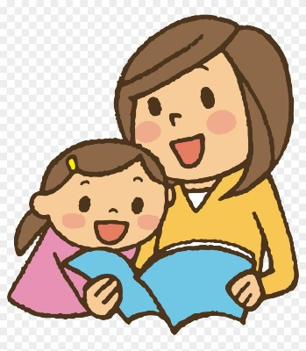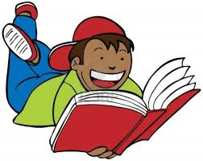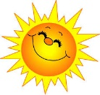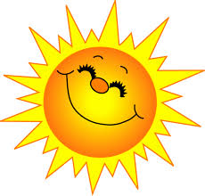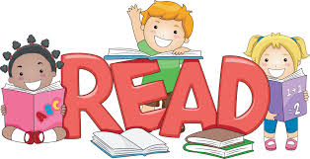

**Reading All Shapes and Sizes.**

Learn some new facts from a book

Read a book with an animal as the main character

Read a recipe

Read a newspaper

Read instructions

Read poetry

Keep your brains in training this summer.

**How many you can tick off the list?**

**Summer Reading Challenge!**

**Reading All Over the Place.**

Read in bed

Read outside

Read in sunglasses

Read standing up

Read to a grown up.

Read to a pet

Read in the park