5th June 2020

Dear Parents and Carers
As you will know we are now trying to slowly increase our numbers at Foxwood but we continue to take a controlled, considered and phased approach. We have detailed risk assessments and operating procedures as well as external ratification of our health and safety systems. Staff and child safety is our number one priority and so we have no intentions to rush you or your children back to school.
At the moment we are slowly integrating our primary aged children and aim (where parents are in agreement) to have all primary aged children back at the Academy before the end of June. This was the initial advice for mainstream primary schools which we decided to mirror.
More recently the government has advised secondary providers to offer some face to face contact for year 10 and year 12 students from the 15th June. Because we are an Academy that has all age groups we are currently unable to offer this until the start of July.
Our plan for July is to start to reintegrate some of the key stage 4 and 5 children (years 10,11,12 and 13). You may have seen in the media that the only way to safely work with children and young people is to work in ‘bubbles’ where the staff and children remain with the same group of people throughout the day. This combined with social distancing, staggered breaks and lunchtimes, strict self-isolating and health and safety procedures creates a number of hurdles that we will endeavour to clear.
The questionnaire HERE is for parents and carers of children in years 10,11,12 and 13 to complete before Friday 12th June to tell us if you wish to take a place back at the Academy sometime between the 29th June and the 20th July 2020. Please let us know if the link doesn’t work for you, some smartphones may not open the document.
It appears that the general advice to parents of key stage 3 children (years 7, 8 and 9) is that these children will need to remain at home for the rest of the term and should return to the Academy in September 2020. If this changes we will contact you.
Kind regards
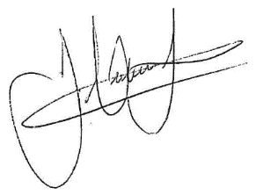
James Hutchinson
Headteacher

