Family Learning:
Adult Learning 19+
Booking Essential
**FREE tuition for people on most means tested benefits (proof required at first session)

Autism Practical Tips for Parents Part 1
Online
This course is for parents, grandparents, relatives, care givers or anyone who cares and supports a child with (or without) a diagnosis of autism. It will offer you an opportunity to gain an understanding about Autism and how it affects everyday life. This is an online course where you can discuss practical tips and share strategies to help support an individual with autism in the comfort of your own home.
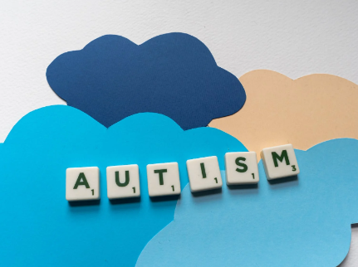

Starts: Wed 4th Jan 2023
Time: 6pm – 8pm
For: 6 Weeks
COST: £36.00

