Preparing for Adulthood Family Information Event

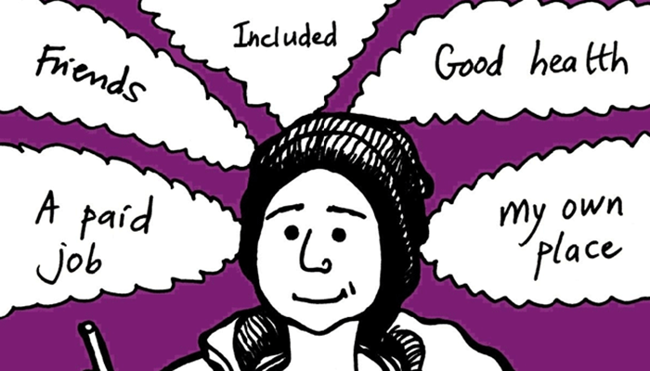
Saturday 19th November 2022
10:00-14:00
Civic Centre, Chesterfield Road South, Mansfield, NG19 7BH
(Refreshments will be provided throughout the day)

This event is an opportunity for young people and their families to meet with services and organisations who are available to support with the move into adulthood with particular focus on Education, Employment & Training pathways for Post 16. There will also be the opportunity to meet a number of young people who have completed Employability study programmes and are now in paid work and to hear their experiences. You will also be able to take part in some practical activities on the day.

If you are interested in attending this event, please complete and return the reply slip in the envelope provided or email us no later than Friday 4th November

We look forward to seeing you all on the day!

Services at the event:

Futures Career Advice & Apprenticeships | Information regarding Supported Employment
Skills For Employment | NCC Transitions Team
Specialist Colleges | Mainstream Colleges
Adult Overnight Short Breaks Services | Independent Travel Training
Information, Advice & Guidance Services | Sports, Leisure & Community Opportunities
Community Short Break Providers | Department For Work and Pensions (DWP) & Job Centre Plus

Please return this reply slip in the envelope provided or to:

PFA Event - ICDS Assessment Team, Meadow House, Littleworth, Mansfield, NG18 2TB

OR

Please Email confirming your attendance to:

ICDS.EHCPost16@nottscc.gov.uk
PFA EVENT REPLY SLIP – Please return to ICDS Post 16 Team
NAME
D.O.B
I will / will not be attending the Preparing for Adulthood Event - (please delete as appropriate)
The following people will be accompanying me | 1
 | 2
 | 3

