
Foxwood Academy
Derby Road, Bramcote, Nottingham, NG9 3GF
Tel: (0115) 9177202
Email: office@foxwood.notts.sch.uk
www.foxwood.notts.sch.uk
Headteacher: Mr James Hutchinson

24th October 2018
Dear Parents/Carers

Much has been made in the media recently of the issues with E-safety and the challenges that those with young children and adults face when trying to ensure their children stay safe online.

I thought I’d write to you to assure you that Foxwood Academy take E-Safety very seriously and list some of the recent adaptations to our curriculum that are in place to help us ensure our children have a healthy relationship with social media.

Firstly, we provide all children and young people with their own email address when they start at the Academy. This way we can monitor (if requested by home) email activity and limit the use of the account where necessary. There are many different ways to set up an email at home; Hotmail, Gmail, ICloud etc. and so having a school account helps prevent spam and allows us to have ‘some’ control. We need to find a balance between giving our young people the independence and right to have online access but also help guide those who are vulnerable.

Secondly, we are one of the few Academies who in addition to providing weekly computing lessons provide weekly lessons dedicated to E-safety. The curriculum that we follow is called ‘Education for a Connected World‘. It is provided by the UK council for child internet safety. Should you wish to look at its content it can easily be found online.

All students have had assemblies on E-safety and it continues to have a high profile across the Academy. Students were recently shown 6 child friendly YouTube clips produced by young people for young people called ‘Staying Safe Online with Lou Carpenter’ I recommend you have a look and talk about them with your children at home.

Finally, can I ask you to vigilant with what your children access online and their social media usage at home. Whilst we all need positive relationships and social media is a good way to maintain friendships, it can also have a problematic side and some of our children are vulnerable to those problems. There are software packages available that allow you as parents to monitor internet usage at home, we can provide details should you need them.

We will be providing more information including the opportunity to complete E-safety training for parents at our family forum in November.

Yours sincerely
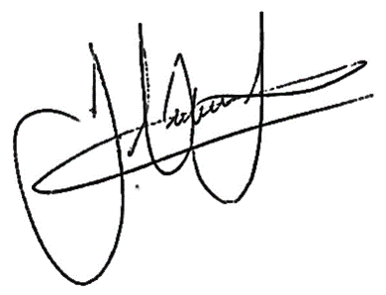
James Hutchinson
Headteacher

